Legal framework of sustainable battery-operated products
Thomas Hofmann *
University of Applied Sciences Nürtingen-Geislingen, Parkstr. 4, 73312 Geislingen an der Steige, Germany

* Corresponding author. Tel.: +49 7331 22 462. E-mail address: thomas.hofmann@hfwu.de
Abstract
The analysis of battery-powered products from different industries shows how sustainable they are. The focus is not only on the batteries, but also on the charging infrastructure and the devices themselves. In addition to the customer's point of view, in particular user behavior, the problem of manufacturers and government intervention options are discussed. Solutions from individual industries are examined for transferability. The modular product architecture and the advantages and disadvantages of standardization are highlighted. Especially the legal framework to support sustainable battery-operated products is introduced.

Keywords: Sustainability, battery-operated, modular product architecture

- Introduction and Motivation
"People want to be flexible and mobile - people don't like cables." This statement is made by the head of a power tool company [1]. Even products such as toothbrushes or headphones, which can be operated by a cable without any problems, are often preferred by buyers to be cordless. For the power tool industry, products with batteries are a benefit-generating trend. The company Bosch states that the share of battery-powered products is already at 40 percent and will probably increase to up to 60 percent in the next five years [2]. The industry for power tools and garden equipment not only recognizes the trend for battery-operated products, but also uses it adequately to strengthen customer loyalty through battery standards, both internally for the company and across companies. However, advantages result not only from the proven brand loyalty of customers [3], but also from internal production cost reductions through standardized batteries. Product diversity that leads to process complexities can be reduced through battery standards.
This development shows that battery systems are now so established among private and commercial users that those users already own batteries and therefore often buy additional power tools without batteries. The industry is reacting, with individual manufacturers increasingly opening up to competitors' rechargeable batteries. This will certainly continue to boost sales of cordless power tools without batteries [4]. Companies in the garden and power tools sector are proving to be among the first compared to other business sectors to standardize on battery systems, and thus with a more customer-focused and greener image. The government also makes regulations in this regard, according to that companies must ensure that the negative impact on the environment is kept to a minimum. Accordingly, every manufacturer of portable batteries is obliged to introduce a self-recovery system and to achieve the prescribed collection rate of 50 percent [5]. The new ecodesign regulations for EU member support to repair instead of throwing away. In order to make products last longer, manufacturers are obliged to provide spare parts for up to ten years. Provided that the product can be disassembled with standard household tools, this will support the lifetime of the products. Also, an extension of the warranty obligation is envisaged, as this will create competition to develop longer-lasting products.
- Scope and objective
What similarities and differences can be identified with regard to the standardization of secondary batteries in different business sectors and what potentials for sustainable development can be identified?
That is the research question of this study covering battery-operated products and their environment, especially:
- the product itself and its architecture,
- its battery, more precisely the secondary battery or often called accumulator and
- the related charging device resp. infrastructure

A variety of small and large appliances of different business sectors were therefore investigated and compared with each other (Tab. 1):
Table 1. Overview of battery-operated products of different business sectors.
Business sector | Investigated examples
Audio/Video | music box, camera
Gaming | consoles, controller
Personal care products | toothbrush, shaver
IT | cell phone, portable computer
Household appliances | window cleaner, vacuum cleaner, security technology, lighting
Garden and power tools | hedge trimmer, lawn mower, screwdriver, hammer drill
E-Mobility | scooter, bicycle, vehicle, truck

For the analysis the following stakeholders were taken into account with their specific interests:
- Customers (personas, case studies)
- Industry (original equipment manufacturer (OEM), supplier, supply chain)
- Government

It became apparent that sometimes the requirements and objectives are in line, but often also conflicts arise between and within a group of stakeholders
For a deeper understanding Germany was used as examination area and the research work was focused onto the topics shown in Tab.2:
Table 2. Focus topics of research work.
Focus topic | Examples
Market | individualization, standardization, unique selling propositions, buying criteria
Product architecture | Modularization, disassembly possibility, exchangeability
Legal framework | BattG, ElektroG, ProdSG, KrWG, LkSG,
User behavior and requirements | Area, degree and duration of usage, duration, convenience
Existing standards | Cordless Alliance System, Power for all alliance, discounter solutions, market dominating companies
International supply chains | lithium, cobalt, graphite
Sustainability | economic, environmental and social aspects
- Market - Individualization, modularization and standardization
Individualized products are necessary in order to meet the specific requirements of customers. Usually, those products are built up from individual stand-alone components or from modules out of a modular kit of variants. The product individualization shows however economical limits, since complexities have to be managed efficiently and profitable at the same time. The possibility to change variants decreases along the development process. Therefore, this is only feasible in the early product development phase. Accordingly, an optimal balance between customer requirements and revenue should already be achieved in the early product planning phase.

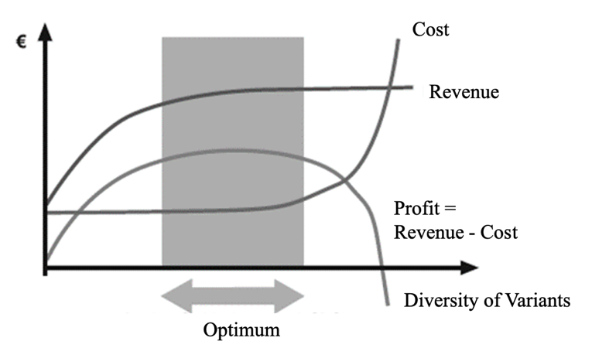
Fig. 1. Optimal diversity of variants
Figure 1 shows the correlation between costs and revenue as the number of variants increases. The difference between costs and revenue results in a parabola, in which the determination of the optimum indicates the range for the optimum number of variants. The increasing product variance offers the customers a higher number of options, which leads to an increase in sales figures. After the revenue has reached a maximum, consumers begin to feel overloaded. A continuously growing variety of products does not offer customers any added value [6]. For the economic model, too much product variance results in smaller batch sizes and a smaller spread of unit costs, until finally the production costs increase rapidly. The aim is to achieve optimal variant management with efficient use of resources. A further instrument, in order to fulfill an optimal product variance with simultaneous management of the complexities, represents the standardized parts strategy. Standardized components can thus be used across different series.
Basically, the motivation of companies to establish a standard is self-initiated and without governmental influence. This is due to the associated cost savings in the manufacturing process. The strategic establishment of standards can even be of great value for companies and thus the gaining of a competitive advantage. On the other hand, cross-manufacturer standards have the disadvantage for companies because of the fact that market entry becomes easier for competitors. The loss of market share goes hand in hand with this.
A fundamental motivation for the introduction of a standard is consumer demand. From the customer's point of view, there are two types of purchasing criteria. Firstly, the investment savings associated with compatibility standards are crucial. Secondly, customers are guided by the market success of the product. In Fig. 2 an investigated example is shown.
If different products have a compatible standard, the users of these products form a so-called installed base. Positive system effects arise as soon as benefit of the product rises. Future demand developments are also important in this context. As the size of the compatibility system of products increases, the number of complementary products also grows.
For competitors, it is difficult to achieve competitive advantages against market leaders in a system technology. The so-called lock-in effect prevents the loss of customers to another technology. For customers, switching to a competitive technology standard means additional costs. The greater the general product variance within a compatibility standard is, the higher the customer loyalty is. System purchasers will decide in favor of the compatibility standard which has the most diverse range of products and accessories. As soon as a company achieves a monopoly-like market position by establishing a standard, it can control the price level for the respective products. The price elasticity of demand corresponds to the level of costs for a technology change to the competitor. With a price increase of 5-10%, customers will tend to replace the product with a substitute. Therefore, if the price of the products is raised above the switching costs, there is a risk of losing customers to competitors.
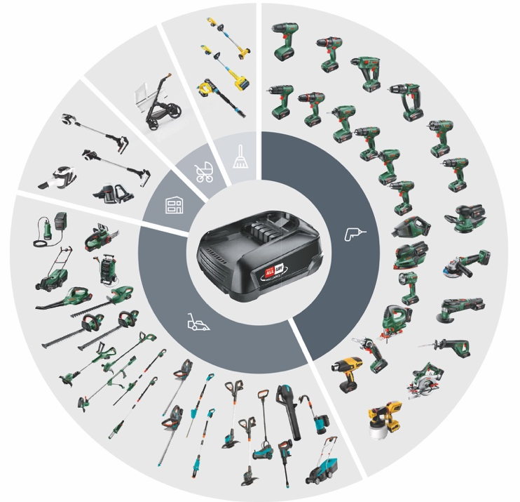
Fig. 2. Product range of the Power for All Alliance [2]
Market leadership for compatibility standards is often formed when the market is entered as a pioneer function and there is no substitution option for consumers. Pioneer companies and the aforementioned switching costs act as barriers to market entry for competitors. The lock-in effect can be overcome by a more optimal price-performance ratio of the competitor's product. This reduces or even compensates the switching costs for consumers.
The introduction of a holistic industry standard, i.e. a standard represented on the market for a product or component, has significant competitive advantages. On the one hand, manufacturing costs for companies are reduced, since large quantities can be produced. On the other hand, interconnectivity between companies is strengthened. The market-leading company can license the standards for complementary products to other manufacturers and thus generate revenue. At the same time, cartel regulations must not be forgotten. When implementing a standardization strategy, the relevant market must first be analyzed in order to avoid restraints for the competition. Every substitutable product means a loss of market share for the competitor. In this context, mutually compatible products exhibit higher substitutability.
- Legal framework
Regulations with relevance to battery management are presented and examined in more detail. Important are definitions of battery types, environmental impacts and prohibitions as well as take-back systems.
Investigating battery-operated products, the battery law (BattG) is essential. This directive has the aim to minimize the environmental impact of batteries as well as used batteries and to contribute to the protection, preservation and improvement of the quality of the environment. The directive establishes the distinction between battery types. A differentiation is made between consumer, industrial and automotive batteries. BattG covers the sale and take-back of batteries. For example, bringing the product into the market is prohibited when use of mercury and cadmium exceeds set limits. Among other topics §4 BattG prescribes the operation of a take-back system for consumer batteries. According to §8 BattG is the recycling of batteries by public waste management or commercial waste battery disposers compulsory. The end user is responsible for disposing of the respective battery separately from municipal waste and in the designated and offered take-back systems (§11 BattG). The recycling of used batteries is specified in §14 BattG. It is stipulated that at least all liquids and acids must be removed during treatment. The calculation of recycling efficiencies is specified [Commission Regulation (EU) No. 493/2012]. Collection targets are defined and for their fulfillment a performance review is compulsory (§15 and §16 BattG). The responsible authority is the Umweltbundesamt (§19 BattG), whose tasks are defined in §20 BattG [7].
Another essential law is the Electrical and Electronic Equipment Act (ElektroG). The law serves to implement the Directive 2012/19/EC on waste electrical and electronic equipment (so-called WEEE Directive). Its implementation is intended to reduce harmful impacts during the development and usage of electrical and electronic equipment. The focus is on reducing the overall impact of resource use and increasing the efficiency of resource use. Concrete obligations are defined for manufacturers, retailers, municipalities, owners and disposal companies. For example, §4 ElektroG requires that the concept of the products is designed in such a way that in particular the reuse, dismantling and recycling of old equipment, its components and materials are taken into account and facilitated [8].
In the context of battery replacement by the customer, the Product Safety Act (ProdSG) also needs to be considered [1]. The main focus of the law is to ensure personal safety and health of consumers (§3 ProdSG) [9].
The aim of the law on Life-Cycle Management (KrWG) is to protect natural resources, people and the environment in the creation and management of waste [1]. Terms like waste are defined as well as reuse, recycle or disposal (§5 KrWG). Also the requirements for the separate collection of materials are described in § 9 KrWG [10].
Furthermore, the act on Corporate Due Diligence Obligation in Supply Chains (LkSG) oblige companies to protect people and the environment along the supply chain [11]. It comes into full effect in 2023 and initially applies to companies with a workforce of 3,000 or more. The introduction of effective risk management is intended to improve control mechanisms. These controls are carried out by the Federal Office of Economics and Export Control (BAFA). It is criticized that the requirements only apply to the company's own business and direct suppliers. In the case of indirect suppliers, the risk analysis required by law only has to be carried out if there is a reason to do so, such as a human rights violation. Another point of criticism is the lack of a liability rule, which makes it difficult for a prosecutor to enforce a company's liability. The protected goods soil, water and air are included in the framework of human rights risks in the law, an expansion in the direction of environmental destruction and biodiversity loss is missing [10].
Finally, the European Green Deal focuses on a sustainable EU economy [12]. The objectives are to promote a more efficient use of resources through the transition to a clean and circular economy to restore biodiversity and to reduce pollution. The aim is to achieve climate neutrality by 2050, which also includes sustainable batteries for a circular and climate-neutral economy. Same requirements should apply to all batteries, regardless of their use case. Requirements such as responsibly sourced materials, limited use of hazardous substances, mandatory usage of recycled material, small carbon footprint, performance, durability, labeling and compliance with collection and recycling requirements are to be met. By increasing legal security, new innovations and technologies should contribute to the development of sustainable batteries.
- User behavior and requirements
Developing and launching battery-operated products is dependent on a broad set of customer requirements. Tab.3 gives an overview and explanations about the investigated criteria.

Table 3. User behavior and product concept.
Criteria | Definition or question
Area of use | Provides information about the mobility factor of the product.  Low means usually stationary or maximum within rooms.  Medium includes indoor as well as outdoor areas, i.e., the area around the house.  High represents unlimited coverage.
Degree of usage | Permanent (clock)  Regular (toothbrush)  Seldom (hedge trimmer)
Duration of usage | long, medium, short
Convenience | Does a wired and cordless option of the product exist in parallel?  Is a wired connection not given as an alternative (e-mobility)
Usability while charging | Can the device be charged and the product used at the same time?

The area of use differs greatly depending on the product. Products such as transportation vehicles, but also often cameras and music boxes are used outside. For cars and electric bicycles in particular, the driving range is a buying criterion. Whereas for example consumer electronics products such as game controller are very limited in their area of use, as the console can only be operated stationary.
Most products do not have an external charging station. Products such as the digital camera and the power tools have usually an external charging station. Here, it could be observed that the external charging station is available when the battery of the device can be changed. This is to ensure that the device can be used with a charged battery while the drained battery is charged independently. In the case of small devices which have a permanently installed battery, there is no external charging station and in most cases the device can also be used during the charging process. All devices examined are charged via a cable connection. Standards, like USB C can be found at some small devices. The large devices such as garden and power tools show various types of interfaces. In addition to the cable connection, only two of the tested devices have an alternative connection, such as induction charging.
Most devices cannot be used during the charging process. An exception here are the music boxes and the controllers of the consoles. For the garden and power tool one or several replacement batteries are used to enlarge the duration of usage while charging in parallel. Especially for products that cannot be charged and used at the same time, there is a high dependency on short charging cycles to ensure optimal performance of the product.
The study shows that battery replacement is usually not possible for a number of products. In addition to the price of the products, the area of use also plays a role in the exchangeability of the battery. For example, the area of use for products such as cameras or electric bicycles is very large compared to devices such as controllers or toothbrushes.
The exchangeability of the battery by the end customer is not foreseen in most products. Here it becomes obvious that the price and the size of the device have an influence on the exchangeability of the battery. In the case of high-priced large appliances, such as electric bicycles and gardening equipment, the battery can be replaced, as is the case with digital cameras. In the case of electric vehicles, the dimensions of the battery are too large to be changed by the consumer. For the small devices, the replacement of the battery is not provided by the OEM. To replace the battery in these devices, it is necessary to use tools.
Internal standardization of rechargeable batteries exists at some manufacturers. Cross-company standardization of rechargeable batteries for large and small appliances could not be found in this analysis.
The position of the batteries in all devices is positioned in such a way that the handling of the product is optimal. In vehicles, they are installed far down in the frame to keep the center of gravity as low as possible. In other devices, the batteries are positioned in such a way that the weight distribution is balanced as much as possible when using the device, thus guaranteeing optimum user comfort.
Especially the positioning, assembly and handling of the battery is of interest (Tab. 4).
Table 4. Handling and use of the battery.
Criteria | Question
Exchangeability of battery | Is the battery accessible to the customer and can it be replaced independently?  If answer option is no, then it is assumed that the device must be shipped back to the supplier or the replacement of the battery is not provided in principle.  Is there a customer service that takes care of the replacement of the battery even after the warranty has expired?  Has the customer to take care about recycling on his own according to the given battery logo?
Need for tools | Are tools required for the customer to replace the battery?  If answer option is yes, then there may be instructions that customers can use to help themselves replace the battery on their own.
Standardized battery | This does not mean standards for a battery, but whether there are standardized batteries for the products that can be used for different devices within the product range of the business sector
Location of battery | The location of the battery provides information on whether there are product architectural barriers to battery standardization across product range, or whether the space and location for battery assembly represents potential.

Currently, two different alliances for standardized battery systems coexist on the market for garden and power tools: The Power for All Alliance and Cordless Alliance System (CAS).
The two competing alliances have the same approach and the technical concepts of the battery pack. They are comparable but not compatible.
Fig. 3. Product architecture of the Power for All Alliance battery [2]
A deeper analysis shows that the standardization alliances are not a horizontal merger of direct competitors. As the alliance between companies as Bosch, Gardena and others shows, it is a merger of a global player with smaller and specialized companies. The cooperation improves purchasing conditions and saves costs due to standardizing batteries. The smaller specialized companies can benefit from the established 18 V standard, which is licensed by Bosch. This results in advantages for both sides. On the one hand the customer range is increased, and on the other hand the company is more oriented towards the needs of the customer. Standardized battery systems result in more intensive customer loyalty and a higher proportion of customer returns. New customers also tend to assume a higher added value from the standard systems than the amount of the switching costs. Once the customer base has decided in favor of a compatibility technology, the lock-in effect tends to prevent the competition from switching to another system.
Finally, the recycling or disposal concept of manufacturers for the battery of the products was examined. It was found that manufacturers of electric bicycles have developed a concept for the batteries at the end of their product life cycle. Overall, little data on recycling was available from OEMs to provide a comprehensive evaluation for the industries studied. Manufacturers of small electrical appliances show little effort to recycle the batteries they use. There is also currently no disposal concept for the automotive industry, which requires the most significant volume of resources for the production of rechargeable batteries.
- Conclusion and outlook
The currently existing legal requirements (BattG, ElektroG, KrWG, ProdSG, LkSG) for a sustainable battery industry, among other things, are elementary requirements. The separation of batteries and electrical waste by type, the waste disposal and take-back concept, the recycling of materials, the ban on certain hazardous substances, the registration and responsibility of manufacturers and the "design for disassembly" are requirements that must result in action. At present, these requirements are not met or are only partially implemented. In current draft of laws and initiatives, such as the LkSG and the "Green Deal", responsibility towards people and the environment therefore plays a major role and is clearly gaining the attention of governments. Increased legal certainty and the implementation of risk management are fundamental measures that must be included in legislation. It is becoming clear that the relevant authorities must carry out more stringent and continuous controls on companies.
Although the legal framework is in place battery recycling, its efficiency and disposal concepts are still a challenge in certain aspects. The automotive industry's challenges can be overcome, for example, by automated disassembly. On the other hand, standardization of batteries is a solution and simplifies their recycling. Concepts such as "design for disassembly" can also be applied to the separation of the components of electrical and electronic equipment and can also contribute to simplifying recycling in this area. However, it remains to be seen to what extent the possible concepts are implemented by manufacturers or are in the interest of manufacturers, or whether compliance with the law is monitored. Not only must the responsibility of the OEMs be strengthened, but also that of the consumers. The careful separation and the correct allocation of the batteries by the customer, should be more strictly controlled. In addition, communication between supplier and customer must be strengthened to avoid incorrect battery disposal. Incentives from product manufacturers in the form of increased take-back systems can promote correct disposal.
The analysis and subsequent evaluation have shown that a standardized system across all fields of application is unrealistic. Nevertheless, it is desirable to implement standardized batteries within individual industries, also under aspects of sustainability and customer satisfaction. A standard system with regard to the batteries that are used is possible, as can be seen in the example of gardening and power tools. Implementation within individual industries can be achieved with the help of cooperation, collaboration and government support. The results of the meta-analysis show, very large differences for the investigated properties of the products.
Without further standardization of batteries, customers will not only dump the battery at the end of its life, but also the entire product, since technical progress makes the replacement battery generally uneconomical. This behavior generates both battery waste and waste of electrical equipment. The standardization of batteries can therefore not only help to avoid battery waste but also contribute significantly to the reduction of electrical waste.
The disadvantage of standardizing batteries, however, can be that innovation in the further development of battery technologies is thwarted, since state regulation cancels out competition.
The battery's exchangeability does not only depend on the field of use, but also on the size and/or price of the device. If a product is very large or expensive, then it is likely that a replaceable battery can be found. This is one of the important findings that could be obtained from the data set. An exception is the electric car, since here a high complexity for the exchange of the battery is given and the battery cannot be exchanged without special equipment. The differences between large and small devices could also be observed in other categories. The difference in power consumption between the products in both categories indicates that a cross-industry standard for a uniform charging infrastructure, such as the USB C standard, is not possible. The differences within the small devices, on the other hand, are very small, which is why a standardization of the battery and the charging infrastructure can be considered here. This would enable the development of recycling methods and a closed economic cycle for the batteries.
Despite the barriers, the evolution of battery technology will continue to be an important factor in the future. Not only government recognizes geological limits of resources, but also companies. Investing in innovations and cooperation at an early stage will certainly pay off for reputation and cost reasons. It was shown that exchangeability of standardized batteries can contribute significantly to the sustainability of battery-operated products.
References
[1] Garbrecht, H. Hersteller setzen auf die kabellose Baustelle. Handelsblatt. 01.04.2017
[2] Robert Bosch Power Tools GmbH. Bosch und Gardena gründen Akku-Allianz. Gerlingen. 14.07.2020.
[3] Linz M, Bartelmus P, Hennicke P, Jungkeit R, Sachs W, Scherhorn G, Wilke G, von Winterfeld U. Von nichts zu viel: Suffizienz gehört zur Zukunftsfähigkeit. Wuppertal Papers 125, Wuppertal Institute for Climate, Environment and Energy. 2002. p. 52.
[4] Kirchner C, Scheib S. Deutsche kaufen Akku-Elektrowerkzeuge immer häufiger ohne Akku. GfK Growth for Knowledge. 2020.
[5] Nigl T, Rutrecht B, Altendorfer M, Scherhaufer S, Meyer I, Sommer M, Beigl P. Lithium-Ionen-Batterien – Kreislaufwirtschaftliche Herausforderungen am Ende des Lebenszyklus und im Recycling. Berg- und Hüttenmännische Monatshefte. 19.02.2021. pp. 144-149.
[6] Zäh, M. Individualisierte Produkte. Komplexität beherrschen in: Entwicklung und Produktion. Berlin Heidelberg: Springer-Verlag. 2006.
[7] Gesetz über das Inverkehrbringen, die Rücknahme und die umweltverträgliche Entsorgung von Batterien und Akkumulatoren (Batteriegesetz - BattG) vom 25. Juni 2009. Bundesgesetzblatt Teil I. 2009. Nr. 36 vom 30.06.2009.
[8] Gesetz über das Inverkehrbringen, die Rücknahme und die umweltverträgliche Entsorgung von Elektro- und Elektronikgeräten (Elektro- und Elektronikgerätegesetz – ElektroG) vom 20. Oktober 2015. Bundesgesetzblatt Teil I. 2015. Nr. 40 vom 23.10.2015
[9] Gesetz über die Bereitstellung von Produkten auf dem Markt (Produktsicherheitsgesetz – ProdSG) vom 27. Juli 2021. Bundesgesetzblatt Teil I. 2021. Nr. 49 vom 30.07.2021.
[10] Gesetz zur Förderung der Kreislaufwirtschaft und Sicherung der umweltverträglichen Bewirtschaftung von Abfällen (Kreislaufwirtschaftsgesetz – KrWG) vom 24. Februar 2012 Bundesgesetzblatt Teil I. 2012. Nr. 10 vom 29.02.2012.
[11] Gesetz über die unternehmerischen Sorgfaltspflichten zur Vermeidung von Menschenrechtsverletzungen in Lieferketten (Lieferkettensorgfaltspflichtengesetz – LkSG) vom 16. Juli 2021. Bundesgesetzblatt Teil I. 2012. Nr. 46 vom 22.07.2021.
[12] European Commission. The European Green Deal. Brussels. 2019.

